**School ERP System**

* **What is School ERP System**

ERP stands for Enterprise Resource Planning. The school ERP system helps a school track and process data and keep a record of daily activities which are happening in the school. It also assists in automating various elements related to the student life cycle while helping lecturers manage their class and exam timetables, hostel room bookings, administrative tasks etc.

* **Tasks become easy after ERP System:**
* Admissions management
* Attendance management
* Fee and payment management
* Hostel management
* Faculty management
* Student information/records system
* Transport management
* Certificate/document management
* Inventory management
* **Modules:**
* **Students:** The students can see their attendance status, Exam reports, update their detail, can get the notices from the school and teachers, can get their class timetable.
* **Teachers:** Teachers can mark attendance of the students, update the class timetable, give notice to the students, make exam reports etc.
* **Admission Department:** In Admission department the new admission student details, admission cancellation, documents of the students will be maintained, and the all-other details of the students will be maintained.
* **Hostel Department:** In Hostel Department the room vacancy details, students room details, pending fees details, rooms completions details, and fees reports of the paid students.
* **Transport Department:** The Transport department will maintain bus details, arrange busses according to the routes, maintain students address, maintain driver’s details and their routes, and transport fees details of the students.
* **Fees department:** The fees department will handle the pending fees of the students and paid fees students details and make their reports.

* **Exam Section:** The exam section will set the exam schedule, generate hall ticket maintain exam centers lists, generate exam reports etc.
* **Admin:** The admin will maintain the all-users Details, Add, update, or delete the user’s details. The admin will maintain the database in the backend.
* **System Modules Diagram**

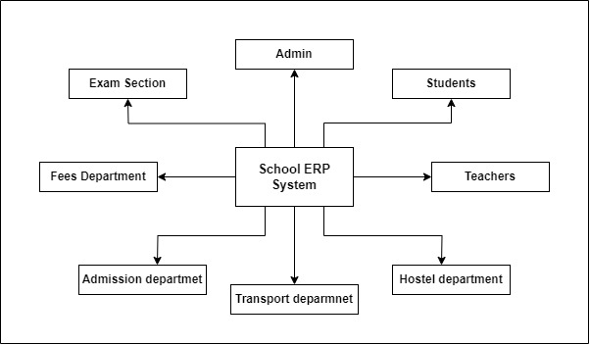

* **Student Module**

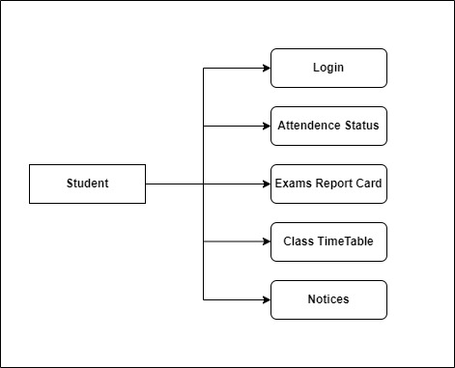

* **Teacher Module**

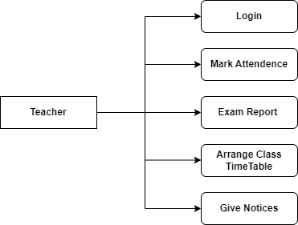

* **Admission Department Module**

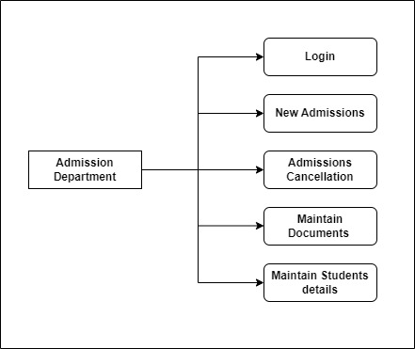

* **Transport Department Module**

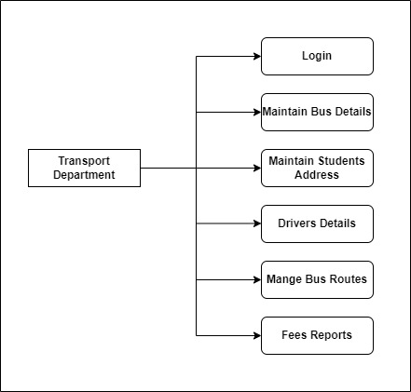

* **Hostel Department Module**

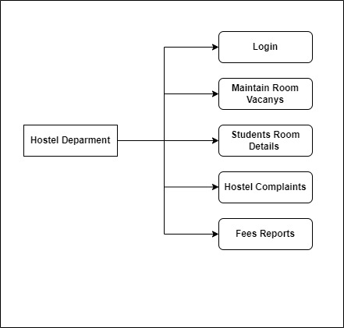

* **Exam Section Module**

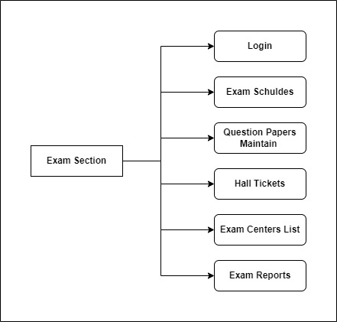

* **Fees Department Module**

